# Figure-3, sh FacultyReport

awk 'BEGIN {

{print "\t\t Faculty at Vanier\n"}

{"date" | getline d}

{printf "\t %s\n", d}

{printf "FacultyID\tFaculty LName\t\tFaculty FName\n"}

{print "========================================================"}

}

{printf " %s\t\t%-10s\t\t%s\n",$1,$2,$3}' faculty

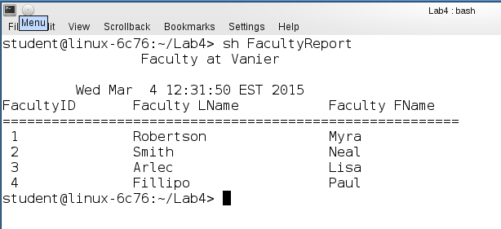

# Figure-4, sh StuFacReport

sort -k5 student > studentSorted

join -1 5 -2 1 studentSorted faculty > stufac

awk 'BEGIN {

{print "\t\t Students and Their Supervisors at Vanier\n"}

{"date" | getline d}

{printf "\t %s\n", d}

{printf "StudentLName\tStudent FName\t\tFaculty LName\n"}

{print "========================================================"}

}

{printf " %-8s\t\t%-8s\t\t%-8s\n",$3,$4,$6}' stufac

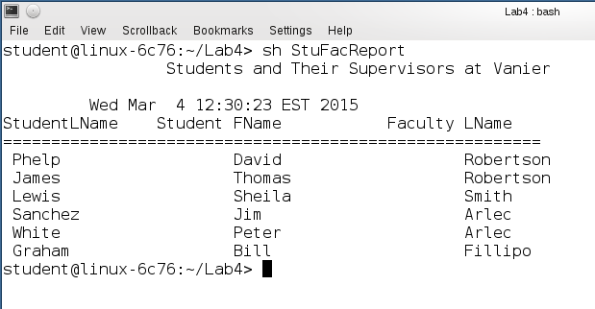

# Figure-5, sh Stud_Enro_Report

sort -k1 student > studentSorted

sort -k1 enrollment > enrollmentSorted

join -1 1 -2 1 studentSorted enrollmentSorted > stuenr

awk 'BEGIN {

{print "\t\t Students and Their Marks at Vanier\n"}

{"date" | getline d}

{printf "\t %s\n", d}

{printf "StudentLName\tStudent FName\t\tCourseNum\tGrade\n"}

{print "============================================================="}

}

{printf " %-8s\t%-8s\t\t%s%-8s\t%s \n",$2,$3,$6,$7,$8}' stuenr

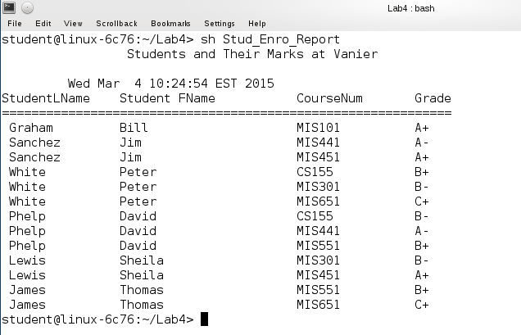

# Figure-6, sh Stud_Enro_faclReport

sort -k1 student > studentSorted

sort -k1 enrollment > enrollmentSorted

join -1 1 -2 1 studentSorted enrollmentSorted > stuenr

sort -k5 stuenr > stuenrSorted

sort -k1 faculty > facultySorted

join -1 5 -2 1 stuenrSorted facultySorted > stuenrfac

awk 'BEGIN {

{print "\t\t Students and Their Marks, with Name of their Supervisors at Vanier\n"}

{"date" | getline d}

{printf "\t %s\n", d}

{printf "StudentLName\tStudent FName\t\tCourseNum\tGrade\tFacLName\tFacFName\n"}

{print "==============================================================================================="}

}

{printf " %-8s\t%-8s\t\t%s%-8s\t%s \t%-8s\t%-8s\n",$2,$3,$6,$7,$8,$9,$10}' stuenrfac

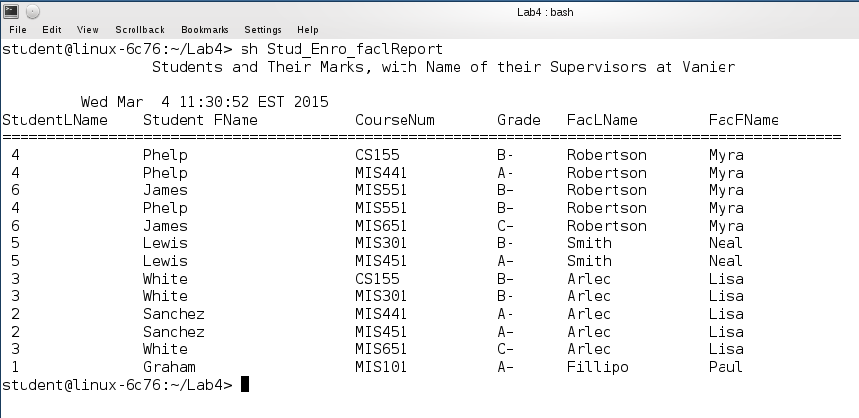

# Figure-7, sh PublisherReport

awk 'BEGIN {

{print "\t\t Publisher at Vanier\n"}

{"date" | getline d}

{printf "\t %s\n", d}

{printf "Publisher ID\tPublisher Name\t\t\tPublisher Address\n"}

{print "=========================================================================="}

}

{printf " %s\t\t%-8s\t\t%s\n",$1,$2,$3}' publisher

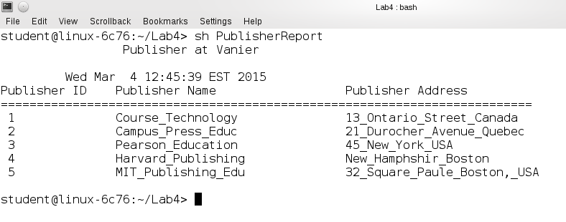

# Figure-7, sh BookReport

awk 'BEGIN {

{print "\t\t List of Books\n"}

{"date" | getline d}

{printf "\t %s\n", d}

{printf "Book ID\tBook Author\t\tBook Titile\t\tBook Price\n"}

{print "=========================================================================="}

}

{printf " %s\t%-8s\t\t%-16s\t%-8s\n",$1,$2,$3,$4}' books

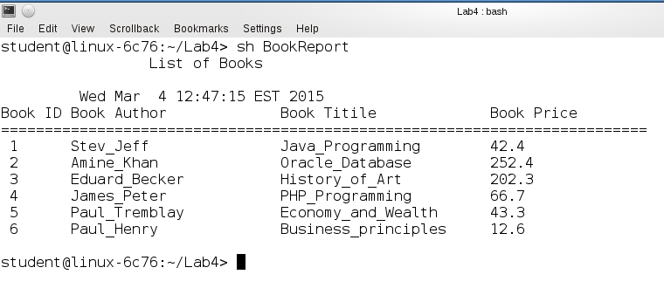

# Figure-8, sh EmployeeReport

awk 'BEGIN {

{print "\t\t List of all Employees \n"}

{"date" | getline d}

{printf "\t %s\n", d}

{printf "Empl ID\tEmployeeLName\t\tEmployeeFName\t\tSalary\n"}

{print "=========================================================================="}

}

{printf " %s\t%-8s\t\t%-16s\t%-8s\n",$1,$2,$3,$5}' employee

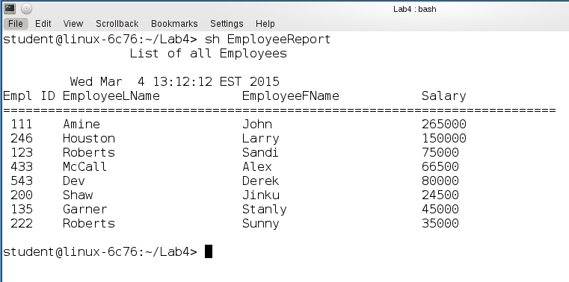

# Figure-9, sh Emp_Dept_Report

sort -k6 employee > employeeSorted

sort -k1 dept > deptSorted

join -1 6 -2 1 employeeSorted deptSorted > empdep

awk 'BEGIN {

{print "\t\t List of all Employees and Their Departmental Affiliation \n"}

{"date" | getline d}

{printf "\t %s\n", d}

{printf "Empl ID\tEmployeeLName\tEmployeeFName\tSalary\t\tDepartment\tLocation\n"}

{print "==============================================================================="}

}

{printf " %s\t%-8s \t%-8s\t%-8s\t%-8s \t%-8s \n",$2,$3,$4,$6,$7,$8}' empdep

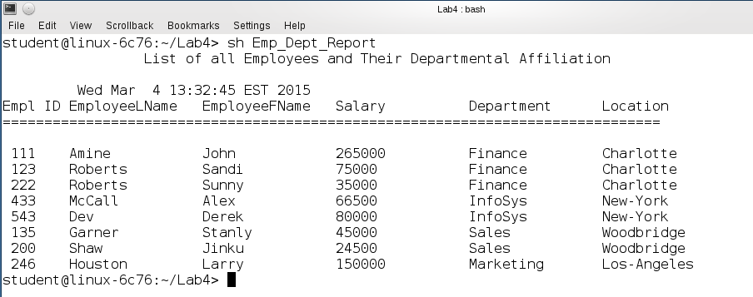

# Figure-10, sh Emp_Dept_Pos_Report

sort -k6 employee > employeeSorted

sort -k1 dept > deptSorted

join -1 6 -2 1 employeeSorted deptSorted > empdep

sort -k5 empdep > empdepSorted

sort -k1 position > positionSorted

join -1 5 -2 1 empdepSorted positionSorted > empdeppos

awk 'BEGIN {

{print "\t\t List of all Employees and Their Departmental Affiliation \n"}

{"date" | getline d}

{printf "\t %s\n", d}

{printf "Empl ID\tEmployeeLName\tEmployeeFName\tSalary\t\tDepartment\tLocation\tPosition\n"}

{print "=================================================================================================="}

}

{printf " %s\t%-8s \t%-8s\t%-8s\t%-8s \t%-8s \t%-8s \n",$3,$4,$5,$6,$7,$8,$9}' empdeppos

